  - PROJECT DESIGN PHASE

Solution Architecture
Date | 29 Septemper 2026
Team ID | 6ab1d50c92b876d9664094bc
Project Name | Auto Ticket Classification Using Flow Designer
Maximum Marks | 4 Marks

Solution Architecture
The proposed architecture uses ServiceNow cloud components. Users create incidents through the ServiceNow interface. A Flow Designer record trigger starts rule-based classification and updates the incident. Tickets without a matching rule are sent for manual review.
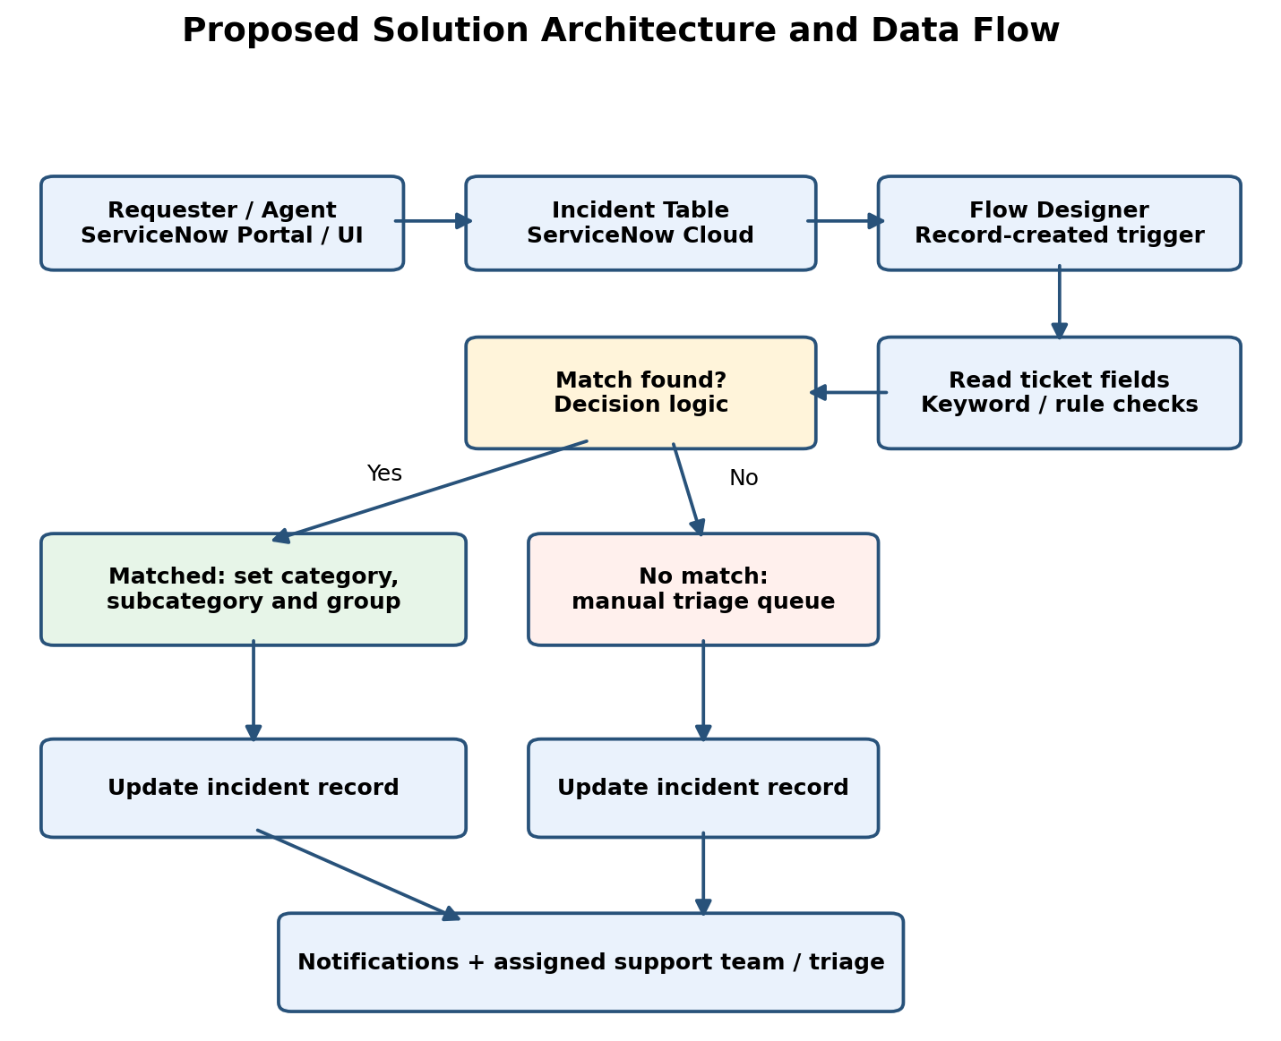
Figure 1: Proposed architecture and ticket data flow.

Architecture Components
Component | Function / Technology
User interface | ServiceNow Employee Center / incident form; ticket submission
Data storage | ServiceNow Incident [incident] table; category, description, assignment and status fields
Automation | ServiceNow Flow Designer; incident-created trigger and decision branches
Classification | Configurable keyword rules on ticket text; unmatched ticket fallback
Routing | Update assignment group and category on the incident
Notification | ServiceNow notifications to relevant support team and requester, where configured
Deployment | ServiceNow cloud instance; no separate server or external API required

Workflow and Design Notes
- Trigger: new incident record is created.
- Read short description and description; evaluate explicit classification rules.
- On a match, populate category, subcategory and assignment group. Calculate priority only according to the organization’s approved impact and urgency policy.
- If no rule matches, route to a manual triage group rather than guessing.
- Update the incident and notify the responsible team; log changes for review.
- Use role-based access and test overlapping rules, blank descriptions, and incorrect routing before deployment.
Implementation note: The diagram represents a proposed solution, not a claim that the flow has already been deployed.

